Name: CAMPUS RESHARE HUB
githubUrl: https://github.com/Akshatkeshri033/Campus-ReShare-Hub.git
description: Campus ReShare Hub is a digital platform designed for college students to report lost and found items and trade second-hand academic products within the campus. The system allows students to post lost items, report found items, and automatically match them to help recover belongings. It also provides a campus-exclusive marketplace where students can buy or sell textbooks, lab equipment, cycles, calculators, and other essentials. By restricting access to verified campus users, the platform ensures trust and security. The system uses smart matching, notifications, and category filtering to simplify item recovery and student resale activities.
Functional Requirements
User Authentication
- Login using campus email/Microsoft 365
- Secure user verification
- Logout functionality
Lost Item Reporting
- Add lost item details
- Upload item image
- Mention location and date
- Store details in database
Found Item Reporting
- Report found items
- Upload found item images
- Save found item details
Smart Matching System
- Compare lost and found items
- Match using:
  - Item name
  - Category
  - Location
  - Date
  - Contact
- Generate match suggestions
Notification System
- Notify users when:
  - Match found
  - Buyer message received
  - Item sold
  - New item added
Student Marketplace
- Upload products for resale
- Add:
  - Price
  - Category
  - Condition
  - Image
- Campus-only access
Category Filters
- Books
- Electronics
- Lab Equipment
- Cycles
- Hostel Items
Chat System
- Buyer and seller communication
- Message notifications
Suspicious Listing Detection
- Compare selling items with lost item database
- Report suspicious items
- Admin review system
Admin Dashboard
- Monitor lost/found reports
- View match statistics
- Manage suspicious listings

Non-Functional Requirements
Security
- Secure authentication
- Campus-only access
- Encrypted user data
Performance
- Fast page loading
- Quick item matching
- Efficient notifications
Reliability
- Minimal downtime
- Safe data storage
Scalability
- Support multiple campuses
- Handle increasing users
Usability
- Simple and user-friendly interface
- Easy item search and navigation
Maintainability
- Easy to update modules
- Future AI integration support
Compatibility
- Works on mobile and desktop
- Supports modern browsers
Availability
- Accessible anytime for students
Data Accuracy
- Accurate item matching
- Updated marketplace information
Sustainability
- Encourages reuse of academic products
problem_statement: Students frequently lose personal belongings and also struggle to buy or sell used academic items within campus safely. There is no centralized platform that helps recover lost items or enables trusted student-to-student resale.
proposed_solution: Campus ReShare Hub is a smart digital platform designed to solve both lost-and-found management and student resale problems within the campus. The system allows students to report lost or found items with images and descriptions, while an AI-based matching system automatically identifies possible matches and sends notifications to users. The platform also includes a secure campus-exclusive marketplace where students can buy, sell, or exchange used academic items such as textbooks, calculators, lab equipment, cycles, and gadgets. By using verified campus authentication, smart matching, category filtering, notifications, and chat features, the system provides a safe, organized, and efficient solution for students.
technologies_used: Firebase, emailjs, html, css, react, javascript, powerBI, copilot ai studio, power automate
system_architecture: 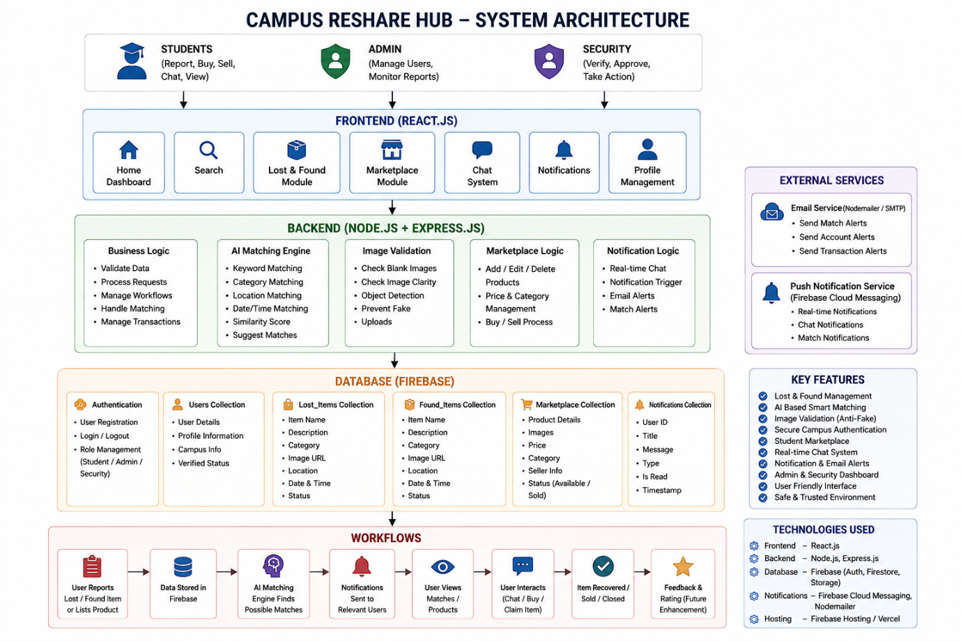

in_scope: Lost item reporting, Found item reporting, Smart item matching, Notification system, Student marketplace, Category filtering, Chat and Call between buyer and seller, Campus-only authentication, Admin dashboard, Suspicious listing reporting.
out_scope: Public marketplace access, Online payment gateway, Delivery services, Multi-language support, Mobile application, External university access, Advanced image recognition AI.
future_enchancements: QR code tagging for personal items, Image-based item search, Mobile app version, Seller reputation system, Campus volunteer delivery support, AI image recognition, Real-time analytics dashboard, Multi-university support.
conclusion: Campus ReShare Hub is an innovative and secure platform that solves two major campus problems: recovering lost items and enabling safe student resale activities. The system combines AI-based smart matching, secure authentication, notifications, and a campus-exclusive marketplace into a single platform. It promotes sustainability, reduces waste, improves student convenience, and has strong potential for deployment across multiple universities.

